- Install the driver for the USB to serial cable (debugging cable) comes with the device from the below link:
http://www.prolific.com.tw/US/ShowProduct.aspx?p_id=225&pcid=41

- Make sure the device is turned off then connect the debugging cable comes with the device to your USB port on your PC at one side and also pin J4 on the sensor board as per below instructions:
- For cylindrical enclosures: rotate the end cap CCW to open the device, make sure the device is turned off by removing the power jumper on J3 (for devices without ON/OFF switch) or turning OFF the ON/OFF switch (for devices with ON/OFF switch) connect the debugging cable to pin J4 as the below picture.

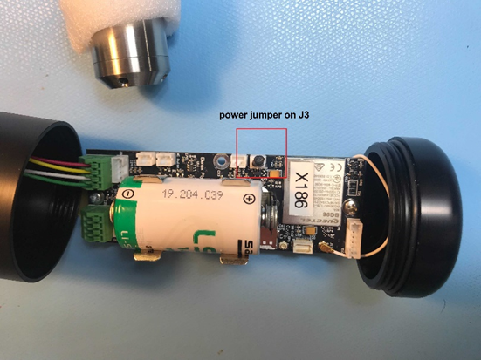

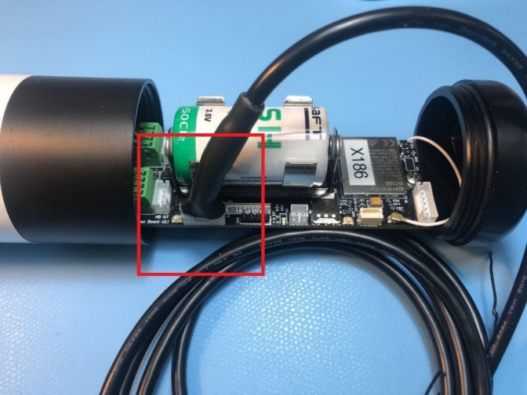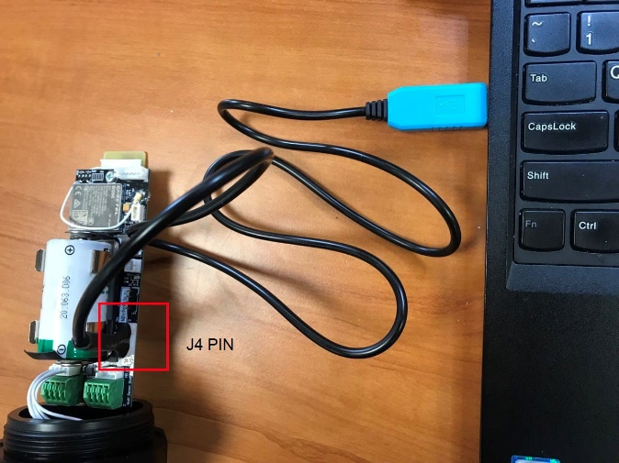

- For rectangular enclosures: turn the device OFF using the ON/OFF switch on the side of the enclosure then open the cap by removing four rubber feet and unscrewing 6 screws from the back of the device then connect the debugging to pin J4 as the below picture:

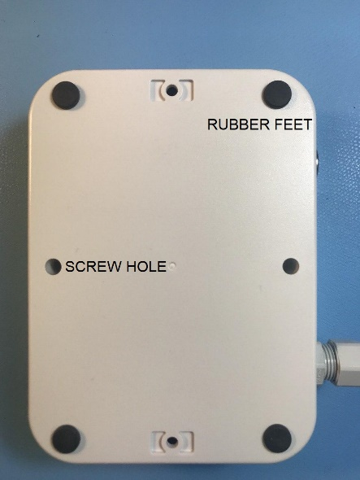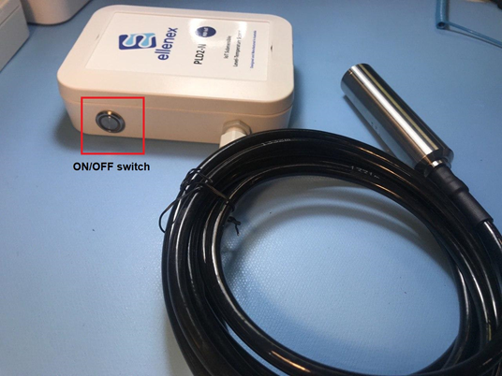

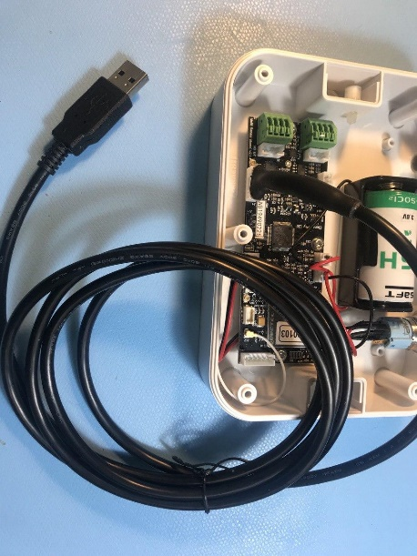

- For rectangular enclosures with 8 pin connectors: turn the device OFF using the ON/OFF switch on the side of the enclosure, connect the debugging cable to the male 8-pin connector on the sensor enclosure as the below picture:
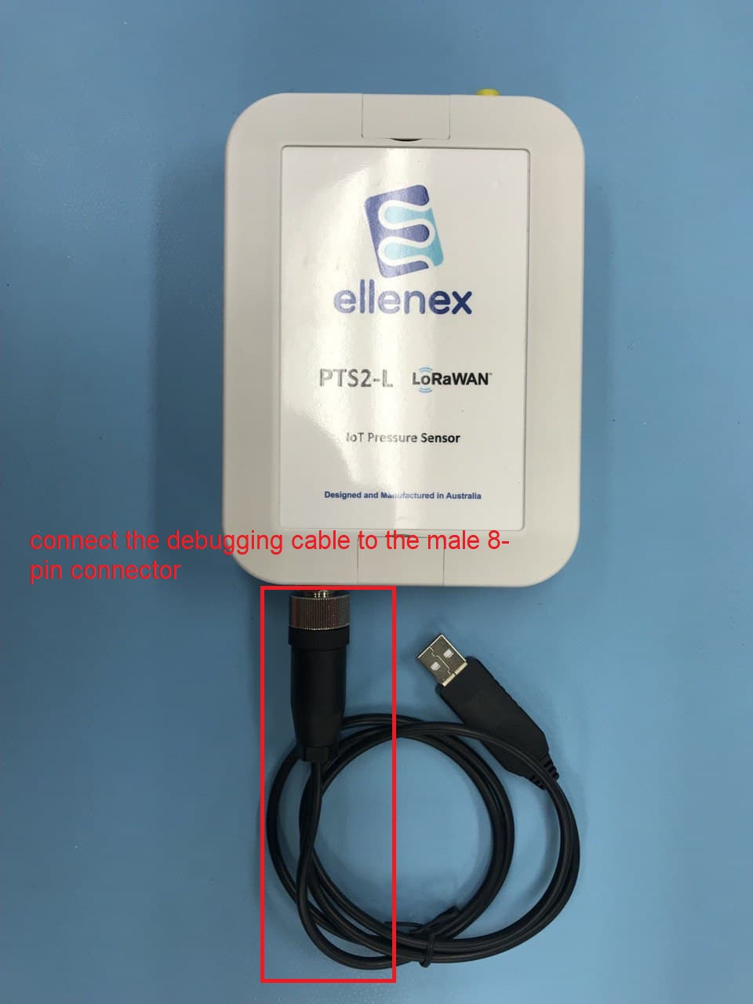

- Open “SensorBootloader” program:
- Choose a serial port to use from the dropdown box and click open port
- Download the configuration file containing the AT commands for the CatM1 and NBIoT network supported in your country (only the countries and operators in the list below list are supported at the moment).
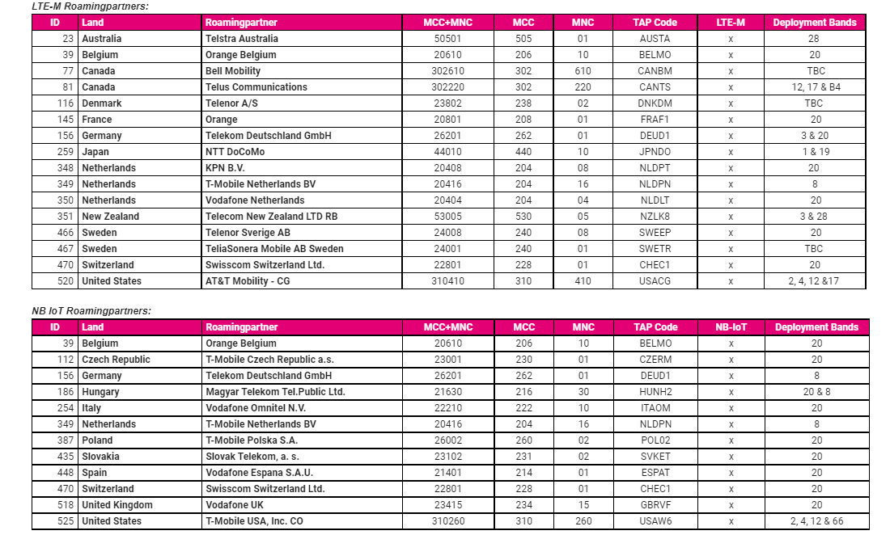

- Click on the button marked "Config and chose the configuration file you have downloaded in the previous step.
- Have the sensor board connected to the serial cable and turn ON the device and click “start”.
- The device can be turned ON by inserting the power jumper back into J3 (for devices without ON/OFF switch) or by pressing ON/OFF switch.
- Note: wait at least 15 seconds between each ON and OFF.

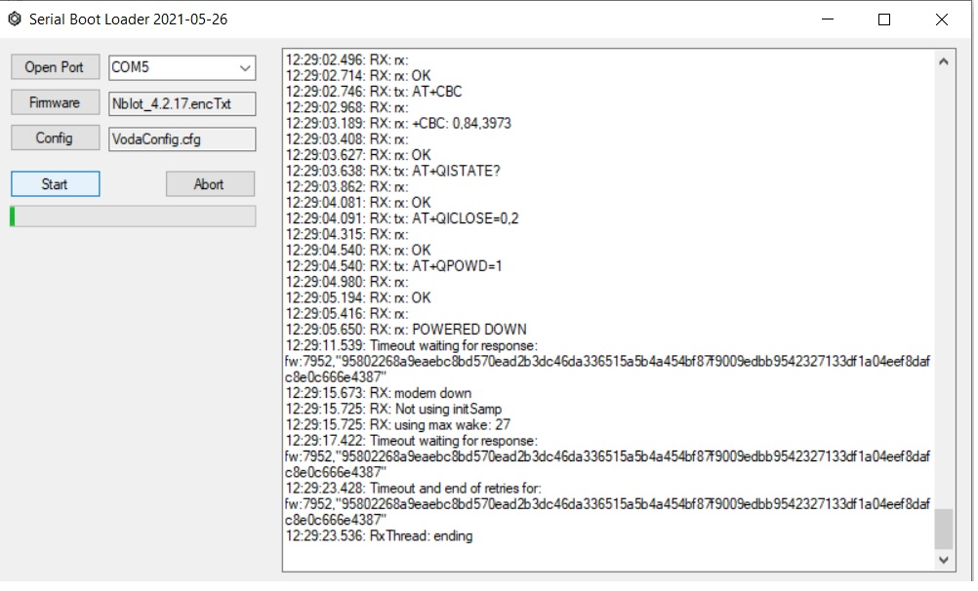

All details are subject to change without prior notice

© All Rights Reserved for Ellenex Pty Ltd
Integrated IoT Solutions

E:sales@ellenex.com
W: www.ellenex.com

